A COMMON CORE STATE STANDARDS ALIGNED CURRICULUM

GUIDE FOR
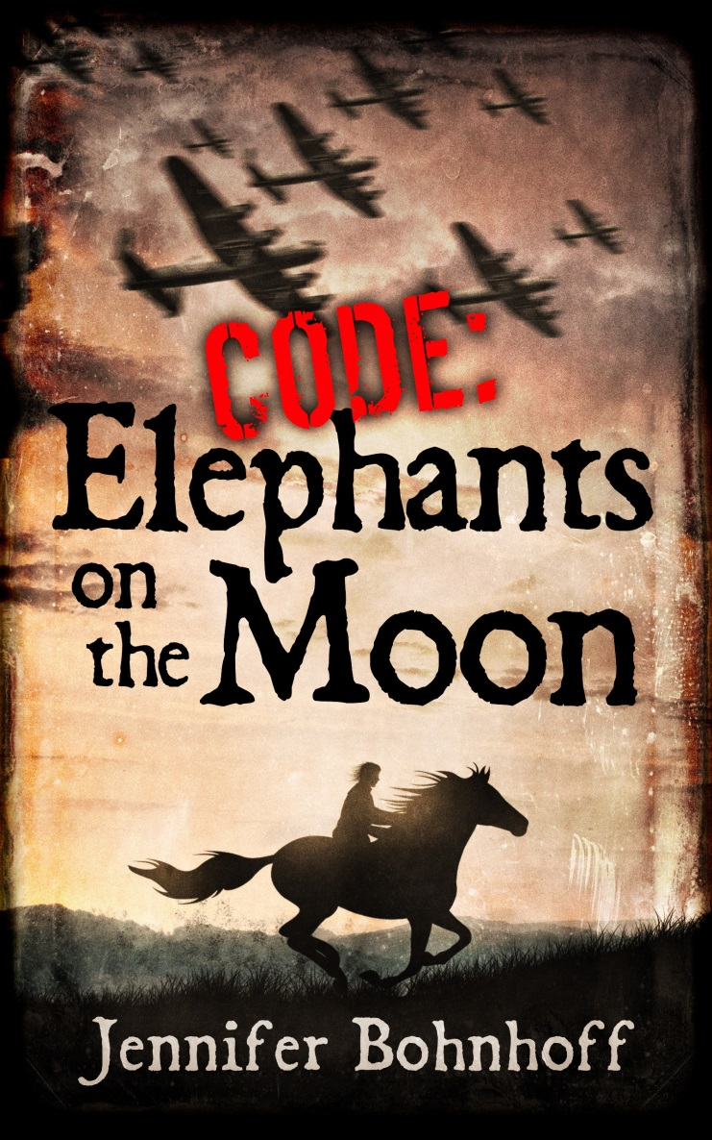

WRITTEN BY JENNIFER BOHNHOFF

A COMMON CORE STATE STANDARDS ALIGNED CURRICULUM GUIDE FOR
CODE: ELEPHANTS ON THE MOON
Jennifer Bohnhoff

Copyright 2014 Jennifer Bohnhoff
This book remains the copyrighted property of the author. It may be reproduced, copied and distributed for non-commercial, educational purposes.
TABLE OF CONTENTS

Synopsis………………………………………………………………………………..………………………………..3
Rationing in Wartime France: Comparing Fiction to Nonfiction………………………………5
Mais, oui! Yes, you can! Using context clues …………………………………………………………6
Plot Map…………………………………………………………………………………………………………………8
Discussion Questions: ……………………………………………....……………………………………………9
Creating a Summary……………………………………………………………………………………………….10
Crossword Puzzle…………………………………………………………………………………………………..11
Using Words to Form Mental Pictures………………………………………………….………………..12
Core Curriculum State Standards Alignment……………………………………….…………………14

Synopsis
Eponine Lambaol wishes she were someone and somewhere else. A red-headed Breton in the provincial Norman village of Amblie, she is an outcast who has only three friends: the equally ostracized Jew Sarah Salomon, who has disappeared along with her family, Rene Bonte, the very handsome son of the mayor, and her homely Breton horse, Galopin.
When she attracts the leering interest of the lonely German soldiers who occupy the area, she gains an unlikely ally in a disillusioned German sergeant. This is Johannes Hegel’s second World War, and he is tired of the bloodshed. He has suffered the same facial disfigurements as Eponine’s WWI veteran father, who is far away, conscripted to build bridges for the Germans.
Eponine’s second cousin, Barb Willocque, has come to live with them while recovering from tuberculosis. A tall, raw boned woman with short cropped hair, her appearance gives the uncharitable neighbors something to gossip about. Keeping the family fed is difficult due to the shortage of rationed foods.
But as rumors of an allied invasion intensify, Eponine discovers that nothing is as she believed. Sarah Salomon is not gone, but hiding in Eponine’s attic. Rene is a Nazi sympathizer with chauvinistic ideas about male/female relationships. Barb is neither her cousin nor tubercular, but a Jehovah’s Witness who has escaped concentration camp. Her mother is not the timid mouse she believed, and the packages that she’s been giving to Father Simon, the Parish Priest, for delivery to her cousins in the city are actually going to the Resistance. When Eponine learns that her father has not been conscripted, but became missing while fighting in the Spanish Civil War, and that he’s not Basque at all, she begins to question her own identity.
Eponine joins the Resistance and forges a new identity for herself. She begins running small errands and engaging in minor reconnaissance trips. Soon she is escorting downed Allied flyers towards freedom. Eponine learns to distinguish between friend and enemy, but not before making some blunders that put her and others in mortal danger.
Eponine receives the coded radio message that lets her know that the invasion is imminent. She and Galopin make a daring midnight ride on which the fate of the village and its freedom fighters will be determined. When a German patrol intercepts her, only Johannes Hegel’s intervention keeps her alive.
In the end, Eponine learns her true identity, and that she has the courage to carry on.

Rationing in Wartime France:
Comparing Fiction to Nonfiction

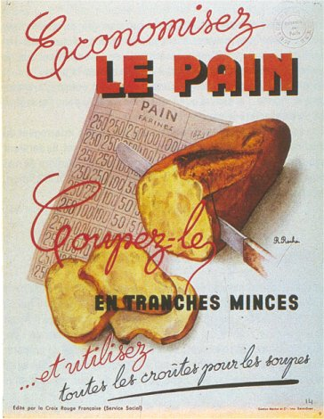
In her blog entry France <3 Food, Taylor Alexandra writes “The rationing system was instituted to ward off inflationary prices and panic. Instead the system and the effects of occupation created endemic food shortages and malnutrition, owing partly to an unequal distribution and availability of foods to the French population. Critical foods like bread, meat, cheese, and milk were rationed, with the daily amount being rationed decreasing as the war continued. Though it varied based on age, occupation, and health, an average person could expect to receive half a loaf of bread, a piece of meat about the size of one’s palm, and a few crumbs of cheese for a daily ration. The pitiful amount of food meant most people would settle for stale bread rather than no bread or the gristle on a piece of meat instead of the actual piece of meat. The food itself was also in a sorry condition – memoirs describe the common sight of “grayish bread and yellowish coffee.” Even alcohol was rationed: the iconic mid-afternoon aperitif was outlawed. France became a much more sober country during the war years.
Translation of French in image:
Save bread! Cut it in thin slices and use the crusts for soups!

As you read Code: Elephants on the Moon, keep a list of ways in which rationing affected the characters.
Go to http://www.bbc.co.uk/schools/primaryhistory/world_war2/food_and_shopping/ for information on rationing in Great Britain during the war. Great resource for primary sources (letters and ration book images) and games that bring home the idea of rationing.

Read more about rationing in France at http://tayloralexandra.wordpress.com/2012/02/18/part-iv-france-3-food-adapting-to-the-ration-system/

Discussion questions: Does the rationing depicted in this novel accurately reflect what you have learned from other sources about rationing? Why or why not?
Think about what you do to buy food and what Eponine did. What additional steps did Eponine have to take in order to buy food because of rationing? What was the purpose of these additional steps?
Mais, oui! Yes, you can!
Using context clues and cognates to understand foreign language in text

Sometimes when you are reading you come across a word you don’t know. Sometimes the word you don’t know isn’t even in English! But that doesn’t mean you can’t figure out what it means.
Using context clues and cognates can help you.

Using context clues means using the words around the one you don’t know.
Using cognates means considering if a word you don’t know is related to a word you do know.

For instance, read the following sentence from Code: Elephants on the Moon and see if you can figure out what the first two words mean:

“Bonjour, mesdames.” Eponine gave the expected greeting even though her heart still battered against her ribcage and her face felt flushed, her hands cold and wet.
“Bonjour, mademoiselle.” Marie and Marthe's heads popped over the top of the display case at exactly the same time.
The words “gave the expected greeting” are a context clue that can help you figure out what those words mean some kind of greeting. The second word, mesdames, is similar to madam. Therefore, “Hello, ladies,” would be a good guess for what “Bonjour, mesdames” means.

What do you think the word “mademoiselle” means? ____________________________________

Now use context clues and cognates to determine what “maman” means. Circle any context clues you used to make your guess.
"Maman, where are you going?" she whined.
"Not me. Us. We must leave Paris."
"Is Papa coming with us?"
Maman looked up, but she didn’t look at her cowering daughter.
Maman means __________________________________________
Read the following paragraph and use context clues to determine the meaning of the word “bocage.”
Rocks shot from Galopin's massive hooves as he galloped toward Amblie. He slowed when he reached the break in the bocage. The shortcut through the wheat field lay on the other side of the break, but Eponine urged him on. The sunken road, hedged in by the bocage and shaded by tall trees, matched her mood. She felt too angry to savor the warmth of the sun on her face, her mind too clouded to face the broad expanse of open sky.

Bocage means ________________________________________________

Circle the context clues in the following sentences that help you understand the underlined word:
But if her stomach didn’t distinguish between a German soldier and a maquisard, a freedom fighter who used guerrilla tactics to harass the Germans, her head did.
Beyond the square lay the mairie, the building which was both the mayor's house and the town offices.
“Bonjour, ma petite roussette.” René used the nickname that only he could, for she knew that he didn't hold her red hair against her.
Look at the underlined words in the excerpts below. Think about context and cognate clues and how all three words end in "rie," and guess what the three words mean. Need some cognate clue hints? Think about or look up butcher, the Spanish word leche (like leche de dulce) and epicure.

Maman snatched at the string bag. “Where is our meat?”
Eponine smacked her forehead with her palm. “I forgot to go to the boucherie.”

In the afternoons Eponine rode Galopin back to Reviers to pick up whatever foodstuffs she was allowed to buy. She watched for little cards in merchant windows announcing that today meat was allowed to Category A, or that Category J3 deserved extra bread from the Boivin Sisters, or milk from the lecherie.

The two SS men who usually stood sentry outside the Boivin sister's bread shop huddled under the overhang in front of the epicerie.

What do you think the -rie means? ______________________________________________

What English words might be cognates of "indic?" What context clues helped you determine this?

_________________________________________________________________________________
“Maybe she’s an indic,” Sophie said. “She passes information to that German with the hideous face.
Use your ability to use context and cognate clues to "translate" these two excepts. Write out your translation on a separate piece of paper.

“Non,” she said, mimicking the action of his hands in his pockets. “C'est tres american.” She mimed pulling her hands from her pockets. “Bon,” she said.

“Shhh.” Eponine whirled around and placed her forefinger in front of her lips. “I hear something. Danger.” She put her hand to her ear, miming her words. The man stopped, warily looking around. He looked as spooked as Galopin. She hoped it was because she had convinced him that danger lurked nearby. “You,” she said, pointing at the man. “There,” she said, pointing toward the bocage.
“Moi?” he asked, pointing a finger at his own chest.
“Oui. Pendant un moment, seulement.” Eponine wasn't sure if he understood exactly, but he crawled into the bushes.

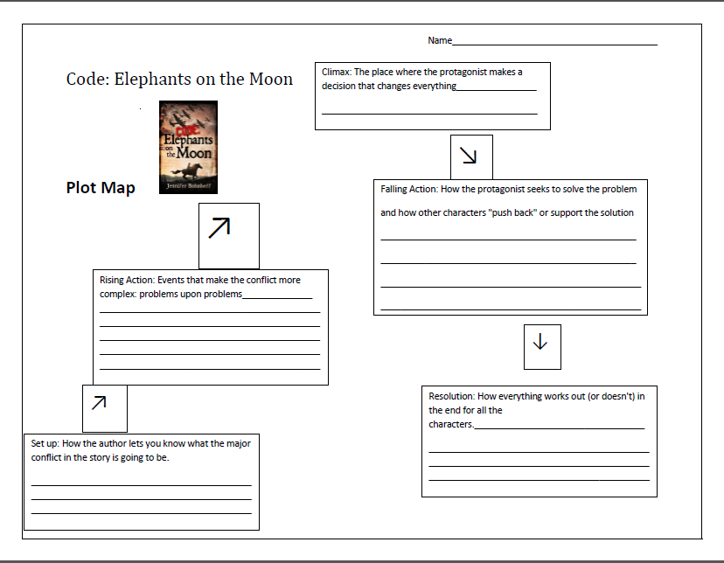
Discussion Guide
The nature of cultural identity
What is a cultural identity?
Does everyone have one?
How does one's cultural identity help define who he or she is?
What is the difference between cultural identity and ethnicity?
Why does Eponine's mother choose to hide their cultural identity? Are these valid reasons?
How would Code: Elephants on the Moon have been different if Eponine had known her cultural identity?

Barbe Willoque shares how the Nazis used scraps of colored cloth to identify different groups:
She pointed to the left side of her chest, right over her heart. “They put a badge on each of us. Right here, so they could see it. Jews wore the same yellow stars they are made to wear outside of camps. Communists wore red rectangles. And we Jehovah's Witnesses wore purple triangles. It was intended to isolate us, but I considered mine a badge of honor, worn near my heart.
This is a form of cultural identity imposed on a group. Is this ever done today? Is it ever a good policy?

Political Views
Study the following excerpts with an eye to the views of the characters regarding service to country. Discuss whose views are based on fact and whose are based on opinion. How do various characters try to persuade others to join them in their views?
Renee and his brother Jacques: “Those maquisards are riffraff and scoundrels.” René shook his head in disgust. “They blow up the train tracks so the government can't bring food to the starving people, and when they slip away, who suffers? Innocent villagers, shot in reprisals because the cowardly maquisards won't stand and fight like men.”
Eponine shifted uneasily on Galopin's back. “Aren’t they fighting for France?”
René's older brother Jacques jostled his way into the window next to René. He wore the khaki shirt, black tie and beret that showed he was a member of the French Militia, which cooperated with the Germans to keep law and order in France. “Fighting for the fun of it, more like. The maquis pillage our farms and rape our women - and take bread from innocent children. We members of the Militia are fighting for France, not those brigands.”

The Maquisard: “My comrades and I would rather stay in the bushes than perform forced labor in a German weapons factory, but we are cold and hungry. Give me loaves of bread and don't complain. Remember when the French were patriotic enough to feed their soldiers? You country people can afford to be generous with your fighters. You have gardens and livestock. In Paris, where I’m from, people eat crows, dogs and cats. Taking your loaves is not stealing; it's requisitioning. But I tell you what; I will leave your family one loaf and my comrades and I will make do with just two. See? We are better than the German pigs. They have taken the whole country.”

Historical Novels and History
Philosopher's George Santayana said “those who cannot remember the past are condemned to repeat it.” What does this mean? What can we learn from the German Occupation of France that would remain an important lesson today?
What is historical fiction? Is it a useful way to learn history? What parts of Code: Elephant on the Moon are made up, and which are likely to be based on actual history?

Creating a Summary
After you have read Code: Elephants on the Moon complete the plot map. Then use the information in the plot map to create a 5-7 paragraph summary of the novel.

Code: Elephants on the Moon
Crossword Puzzle
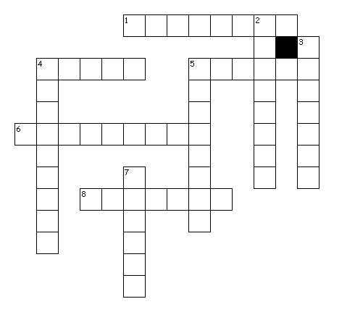
Across
1. area where Breton is spoken
4. French word for mother
5. French Town Hall
6. German Airforce
8. Protagonist's name
Down
2. where Normans come from
3. the German secret police
4. French Freedom fighter
5. French cookie
7. French word for a hedge

Using Words to Form Mental Pictures
As you read the description of Galopin from Code: Elephants on the Moon, circle words that help you gain a mental picture of the horse:

Eponine slammed the door behind her and stomped to the cow barn. “You aren’t mangy,” she muttered as she brushed the knots out of Galopin's tail. Galopin brought his ears forward as if he were really listening. “Old, yes, but you can still plow a field and canter to town. Hortense may gallop faster, but she can't pull a plow. And you aren't as handsome and lithe as she is, but Bretons are bred for strength, not beauty. Us Bretons must stick together.”
The Nazis hadn't confiscated Galopin because they wanted the cabbages and peas he carted to town more than they wanted an odd, old horse, so it was good that he was who he was. And it was good that the Bontés were who they were as well, or the beautiful Hortense would have been taken away long ago, just like the neighborhood’s cows and horses. Being Monsieur le Maire had its privileges.
Eponine brushed Galopin's broad, stubby body and his short, stocky legs. She threw her arms around his massive neck and giggled, remembering how René had teased her last summer when the two of them stopped riding to let their horses drink from a stream. Don't get off his back, he cautioned. If you do, the weight of his head is going to bring his back legs off the ground. That René. Always making jokes.

www.learn-about-horses.com/breton-horse.html says that "the Breton horse is stocky and has rather short legs for its lanky height of 15-16.1hh, but despite this it has a lively trot and seems to enjoy being active."
www.horseshowcentral.com/draft_breeds/Breton describes the Breton like this: "The body outline of the Breton is attractive, short and square, strong and deep. The hindquarters show great strength and the tail is most often docked. The square-ish head of the Breton horse has a straight profile, large open nostrils and kindly eyes. The nose is straight and sometimes dished. The ears are small, mobile and set low on the head.

The Breton's neck is strong, slightly short but arched and set well into the withers. The shoulders are shorter than one might expect, yet the action is fast and free at both the walk and the trot. The limbs are short, strong, and very, very muscular in the thighs and forearms, with short , sound cannon bones.

The coloring is characteristically chestnut or chestnut roan, most often with a flaxen mane and tail."

Look at these pictures of horses. Use the descriptions above to determine which of the horses is a Breton. Be ready to defend your decision.
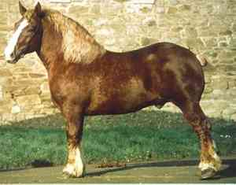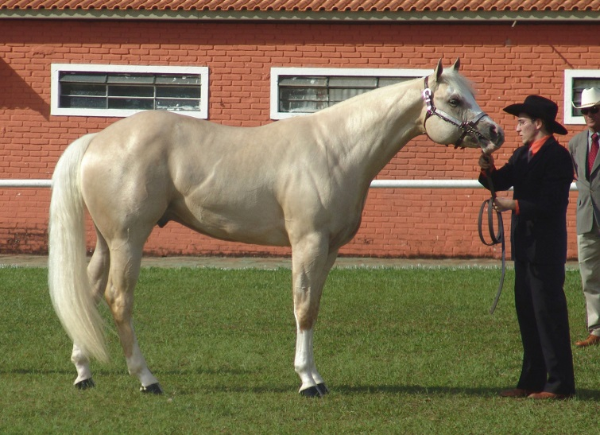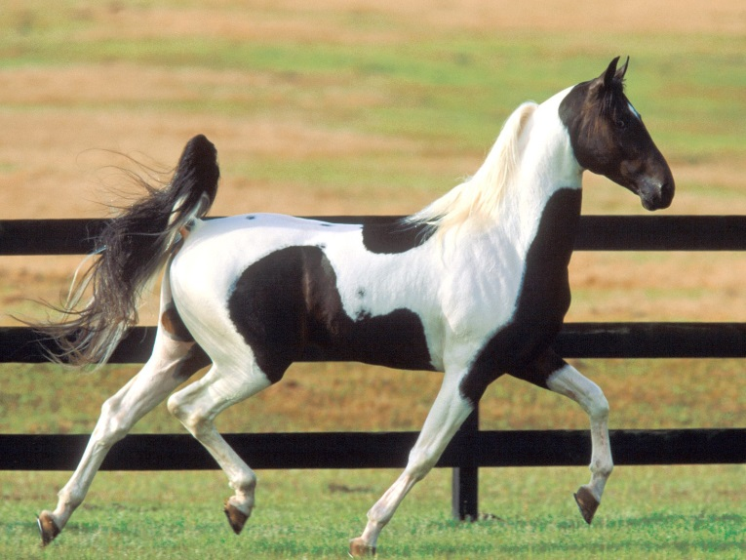

CORE CURRICULUM STATE STANDARDS ALIGNMENT

Key Ideas and Details:

English Language Arts Standards » History/Social Studies » Grade 6-8
CCSS.ELA-LITERACY.RH.6-8.1
Cite specific textual evidence to support analysis of primary and secondary sources.

English Language Arts Standards » Reading: Literature » Grades 6-8
CCSS.ELA-LITERACY.RL.6.1
Cite textual evidence to support analysis of what the text says explicitly as well as inferences drawn from the text.

CCSS.ELA-LITERACY.RL.7.1
Cite several pieces of textual evidence to support analysis of what the text says explicitly as well as inferences drawn from the text.
CCSS.ELA-LITERACY.RL.8.1
Cite the textual evidence that most strongly supports an analysis of what the text says explicitly as well as inferences drawn from the text.

Activities to Support this Standard:
Rationing in Wartime France: Comparing Fiction to Nonfiction………………………………5
Mais, oui! Yes, you can! Using context clues …………………………………………………………6
Discussion Questions: Political Views….. …………………..……………………………………………9
Discussion Questions: Historical Novels and History...……………………………..……………10
Using Words to Form Mental Pictures…………………………………………………………………..12

English Language Arts Standards » History/Social Studies » Grade 6-8

CCSS.ELA-LITERACY.RH.6-8.2
Determine the central ideas or information of a primary or secondary source; provide an accurate summary of the source distinct from prior knowledge or opinions.

English Language Arts Standards » Reading: Literature » Grades 6-8
CCSS.ELA-LITERACY.RL.6.2
Determine a theme or central idea of a text and how it is conveyed through particular details; provide a summary of the text distinct from personal opinions or judgments.
CCSS.ELA-LITERACY.RL.7.2
Determine a theme or central idea of a text and analyze its development over the course of the text; provide an objective summary of the text.
CCSS.ELA-LITERACY.RL.8.2
Determine a theme or central idea of a text and analyze its development over the course of the text, including its relationship to the characters, setting, and plot; provide an objective summary of the text.
English Language Arts Standards » Reading: Literature » Grades 6-8

Activities to Support this Standard:
Discussion Questions: The Nature of Cultural Identity………………………………………..……9 Creating a Summary……………………………………………………………………………………………….10

English Language Arts Standards » History/Social Studies » Grade 6-8
CCSS.ELA-LITERACY.RH.6-8.3
Identify key steps in a text's description of a process related to history/social studies (e.g., how a bill becomes law, how interest rates are raised or lowered).

English Language Arts Standards » Reading: Literature » Grades 6-8
CCSS.ELA-LITERACY.RL.6.3
Describe how a particular story's or drama's plot unfolds in a series of episodes as well as how the characters respond or change as the plot moves toward a resolution.
CCSS.ELA-LITERACY.RL.7.3
Analyze how particular elements of a story or drama interact (e.g., how setting shapes the characters or plot).
CCSS.ELA-LITERACY.RL.8.3
Analyze how particular lines of dialogue or incidents in a story or drama propel the action, reveal aspects of a character, or provoke a decision.

Activities to Support this Standard:
Rationing in Wartime France: Comparing Fiction to Nonfiction………………………………5
Plot Map…………………………………………………………………………………………………………………8

Craft and Structure:

English Language Arts Standards » History/Social Studies » Grade 6-8
CCSS.ELA-LITERACY.RH.6-8.4
Determine the meaning of words and phrases as they are used in a text, including vocabulary specific to domains related to history/social studies.

English Language Arts Standards » Reading: Literature » Grades 6-8
CCSS.ELA-LITERACY.RL.6.4
Determine the meaning of words and phrases as they are used in a text, including figurative and connotative meanings; analyze the impact of a specific word choice on meaning and tone.
CCSS.ELA-LITERACY.RL.7.4
Determine the meaning of words and phrases as they are used in a text, including figurative and connotative meanings; analyze the impact of rhymes and other repetitions of sounds (e.g., alliteration) on a specific verse or stanza of a poem or section of a story or drama.
CCSS.ELA-LITERACY.RL.8.4
Determine the meaning of words and phrases as they are used in a text, including figurative and connotative meanings; analyze the impact of specific word choices on meaning and tone, including analogies or allusions to other texts.

Activities to Support this Standard:
Mais, oui! Yes, you can! Using context clues …………………………………………………………6
Crossword Puzzle…………………………………………………………………………………………..………10
Using Words to Form Mental Pictures…………………………………………………………………..12

English Language Arts Standards » History/Social Studies » Grade 6-8

CCSS.ELA-LITERACY.RH.6-8.5
Describe how a text presents information (e.g., sequentially, comparatively, causally).

English Language Arts Standards » Reading: Literature » Grades 6-8
CCSS.ELA-LITERACY.RL.6.5
Analyze how a particular sentence, chapter, scene, or stanza fits into the overall structure of a text and contributes to the development of the theme, setting, or plot.
CCSS.ELA-LITERACY.RL.7.5
Analyze how a drama's or poem's form or structure (e.g., soliloquy, sonnet) contributes to its meaning
CCSS.ELA-LITERACY.RL.8.5
Compare and contrast the structure of two or more texts and analyze how the differing structure of each text contributes to its meaning and style.

Activities to Support this Standard:

Mais, oui! Yes, you can! Using context clues …………………………………….……………………6
Discussion Questions: The Nature of Cultural Identity…………………………..…………………9
Discussion Questions: Historical Novels and History...……………………………………………10
Creating a Summary……………………………………………………………………………………………….10

English Language Arts Standards » History/Social Studies » Grade 6-8
CCSS.ELA-LITERACY.RH.6-8.6
Identify aspects of a text that reveal an author's point of view or purpose (e.g., loaded language, inclusion or avoidance of particular facts).

English Language Arts Standards » Reading: Literature » Grades 6-8
CCSS.ELA-LITERACY.RL.6.6
Explain how an author develops the point of view of the narrator or speaker in a text.
CCSS.ELA-LITERACY.RL.7.6
Analyze how an author develops and contrasts the points of view of different characters or narrators in a text.
CCSS.ELA-LITERACY.RL.8.6
Analyze how differences in the points of view of the characters and the audience or reader (e.g., created through the use of dramatic irony) create such effects as suspense or humor

Activities to Support this Standard:
Discussion Questions: The Nature of Cultural Identity……………………………………………9
Discussion Questions: Political Views…..…………………..……………………………………………9

Integration of Knowledge and Ideas:

English Language Arts Standards » History/Social Studies » Grade 6-8

CCSS.ELA-LITERACY.RH.6-8.7
Integrate visual information (e.g., in charts, graphs, photographs, videos, or maps) with other information in print and digital texts.

English Language Arts Standards » Reading: Literature » Grades 6-8
CCSS.ELA-LITERACY.RL.6.7
Compare and contrast the experience of reading a story, drama, or poem to listening to or viewing an audio, video, or live version of the text, including contrasting what they "see" and "hear" when reading the text to what they perceive when they listen or watch.
CCSS.ELA-LITERACY.RL.7.7
Compare and contrast a written story, drama, or poem to its audio, filmed, staged, or multimedia version, analyzing the effects of techniques unique to each medium (e.g., lighting, sound, color, or camera focus and angles in a film).
CCSS.ELA-LITERACY.RL.8.7
Analyze the extent to which a filmed or live production of a story or drama stays faithful to or departs from the text or script, evaluating the choices made by the director or actors.

Activities to Support this Standard:
Using Words to Form Mental Pictures…………………………………………………………………..12

English Language Arts Standards » History/Social Studies » Grade 6-8
CCSS.ELA-LITERACY.RH.6-8.8
Distinguish among fact, opinion, and reasoned judgment in a text.

English Language Arts Standards » Reading: Literature » Grades 6-8
CCSS.ELA-LITERACY.RL.6.8
(RL.6.8 not applicable to literature)
CCSS.ELA-LITERACY.RL.7.8
(RL.7.8 not applicable to literature)
CCSS.ELA-LITERACY.RL.8.8
(RL.8.8 not applicable to literature)

Activities to Support this Standard:
Discussion Questions: The Nature of Cultural Identity……………………………………………9
Discussion Questions: Political Views…..…………………..……………………………………………9
Discussion Questions: Historical Novels and History...…………………………………………10

English Language Arts Standards » History/Social Studies » Grade 6-8
CCSS.ELA-LITERACY.RH.6-8.9
Analyze the relationship between a primary and secondary source on the same topic.

English Language Arts Standards » Reading: Literature » Grades 6-8
CCSS.ELA-LITERACY.RL.6.9
Compare and contrast texts in different forms or genres (e.g., stories and poems; historical novels and fantasy stories) in terms of their approaches to similar themes and topics.
CCSS.ELA-LITERACY.RL.7.9
Compare and contrast a fictional portrayal of a time, place, or character and a historical account of the same period as a means of understanding how authors of fiction use or alter history.
CCSS.ELA-LITERACY.RL.8.9
Analyze how a modern work of fiction draws on themes, patterns of events, or character types from myths, traditional stories, or religious works such as the Bible, including describing how the material is rendered new.

Activities to Support this Standard:
Rationing in Wartime France: Comparing Fiction to Nonfiction………………………………5
Using Words to Form Mental Pictures…………………………………………………………………..12

Range of Reading and Level of Text Complexity:

English Language Arts Standards » History/Social Studies » Grade 6-8
CCSS.ELA-LITERACY.RH.6-8.10
By the end of grade 8, read and comprehend history/social studies texts in the grades 6-8 text complexity band independently and proficiently.

English Language Arts Standards » Reading: Literature » Grades 6-8
CCSS.ELA-LITERACY.RL.6.10
By the end of the year, read and comprehend literature, including stories, dramas, and poems, in the grades 6-8 text complexity band proficiently, with scaffolding as needed at the high end of the range.

CCSS.ELA-LITERACY.RL.7.10
By the end of the year, read and comprehend literature, including stories, dramas, and poems, in the grades 6-8 text complexity band proficiently, with scaffolding as needed at the high end of the range.

CCSS.ELA-LITERACY.RL.8.10
By the end of the year, read and comprehend literature, including stories, dramas, and poems, at the high end of grades 6-8 text complexity band independently and proficiently.

For Further Reading

A list of related books and websites is available on the author's website: www.jenniferbohnhoff.com

